Instructions for using My Event
Go to myevent.dacdb.com. Use the event code you received in your zoom notification. Please note in the instructions below the code used will be different than the one you use.
Enter your Event Code then log in using your DACdb login or use your email address that you registered with and the password Rotary2021.
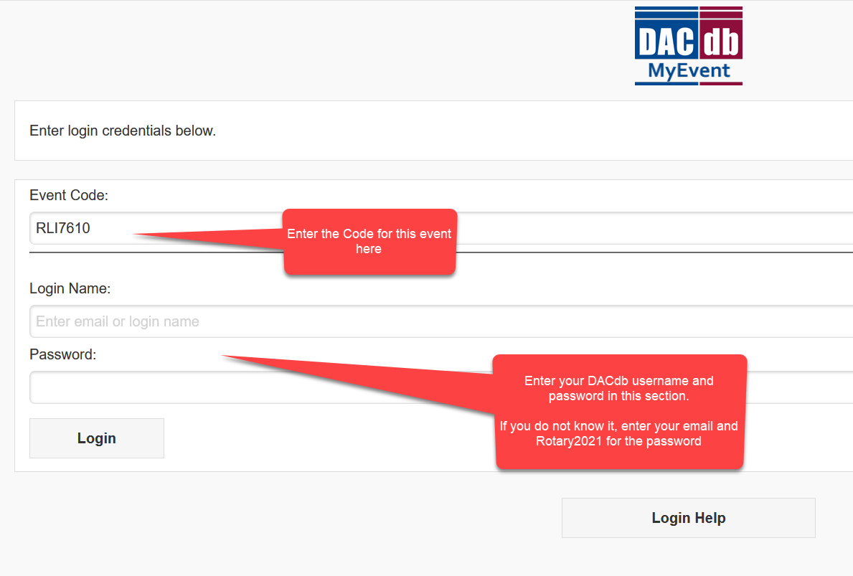

Keep this open on another browser window on your computer.
Once logged in you will see the menu – this is an electronic program
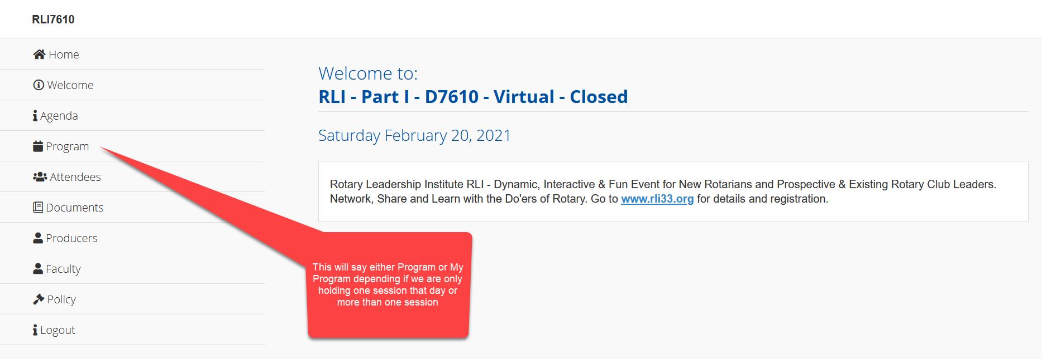
You will click on Program or My Program depending on if we are holding only one part that day or several parts that day.
Click on the Program to sign in to zoom or use the link that was sent to you via email.
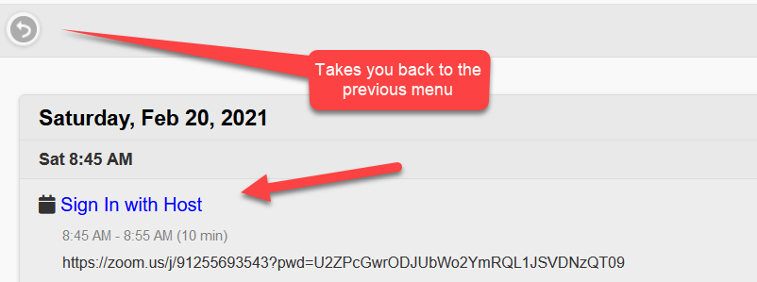

Use the back arrow to go to the previous menu.
In My Event you will see various items that will be used throughout the training such as Agenda, Faculty Bios, Producer Bios, links, surveys, etc.
This is your electronic program

